**Eighth Weekly Assignment: “Why the UBI?”**

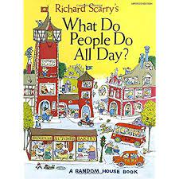

The American Time Use Survey ([ATUS](https://www.bls.gov/tus/)) has been in operation since 2003, and it is a very extensive survey conducted by the Bureau of Labor Statistics to track how Americans spend their time. We will ask you to spend some time checking it out.

The most recent $1.9 trillion “Covid Relief” bill has some elements of it that resemble what a “Universal Basic Income” might be. Many Americans are getting $1,400 checks from the government, unconditionally. There have been [some costs](https://www.nytimes.com/2021/03/16/us/indianapolis-stimulus-shooting-arrest.html) of this too.

Before we have you spend a little time in the data above, we would like you to ponder a little bit about the “Universal Basic Income.” Now the UBI has taken many names over the years, but it is not really a very new idea. It has been proposed and defended by economists of all political stripes, just as it has been opposed by economists of all political stripes.

The simplest idea is that every American (or some portion?) should get a monthly check from the government that would cover basic living expenses. We could means-test the UBI by turning it into something like Milton Friedman’s “Negative Income Tax”, there are many ways one could take this. Some proponents wish to see the UBI layered *on top* of the existing welfare state (how?) while others recommend replacing much of the welfare state apparatus with the UBI.

For now, I do not wish you to get bogged down in the details, or even the ultimate costs of this thing from a dollars standpoint. Just assume we are talking about giving many/all Americans a monthly check.

**PART ONE:** Please address the following prompts:

**One:** Suppose you wish us to have more money with which to fund a UBI than is currently available in our government budgets. Is there currently a socially harmful activity that is not being taxed, or perhaps even being subsidized, that perhaps we could use to fund more of the UBI? Explain.

**Two:** Spend some time thinking through the UBI, and the role that incentives play in economics and politics. While I would prefer you don’t “google around” I suspect you will. Can you articulate at least **three** defenses of a Universal Basic Income? Explain them.

**Three:** Spend some time thinking through the UBI, and the role that incentives play in economics and politics. While I would prefer you don’t “google around” I suspect you will. Can you articulate at least three reasons you would oppose a Universal Basic Income? Explain them.

**Four:** Let’s think ahead to what we called in Eco 108 the Econ 3.0 world that embraces the very best of what the idea of a UBI is, and what the obvious downsides are. How could we deliver an income guarantee, or some stake in the overall well-being in the economy, that is not a traditional UBI.

**PART TWO:** What Do We Do With Our Time All Day?

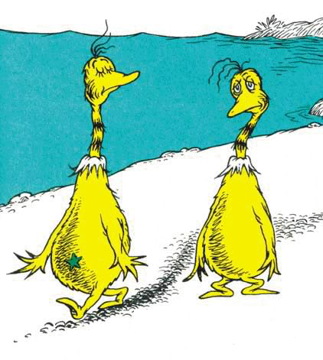

The American Time Use Survey provides with data on how apx. 10,000 American adults spend their days, from the moment they wake up to the time they fall asleep. We are going to have you examine some cross-sectional data on time use, though for fun you may want to see how time use has changed over time.

**Five:** Let’s start by examining time use for the Civilian Noninstitutional Population Aged 15 and Over and examining some of the summary tables/charts they report.

1. What time of day are Americans least likely to be asleep (they report it hour by hour, so we are looking for a specific time)?
2. For those individuals who participate in the activity, how much time on weekdays and weekends do people report helping their children with their childrens’ education? What do you think of that estimate?
3. Volunteering activities: There is a large difference between the average hours per day that Americans spend on Volunteering in Organizational and Civic Activities, and the hours spent in those activities by those who do them. Illustrate this difference and explain.
4. Compare the time spent per day by men who were full-time employed versus men who were not employed (there is a chart you can download and show). What stands out about the chart?

**Six:** Now we would like you to make use of the American Time Use Database directly. We want you to examine the time use patterns of men aged 15 and older who are not employed (ideally we could refine this, but it would require a LOT more data work).

1. How much time do unemployed men spend on housework on a typical day, and how does this compare to the time spent on housework by full-time *employed* women.
2. Compare the time spent by unemployed men on “Socializing, Relaxing, and Leisure” with the time spent by fully employed women on the same activities.
3. How much time per day do unemployed men spend on educational activities each day?

**Seven:** We would actually like to explore a finer subgroup of males. To say that you are “not employed” it may mean that you are in the labor force and looking for work, but not able to find it. But we want to understand what the daily activities of someone who is “not in the labor force” looks like. These are individuals who are not working OR looking for work. But even this category obfuscates the underlying populations – some of these people not in the labor force will be training or educating themselves, and some of them are neither working nor involved in any education or training. The latter group, in the United Kingdom, is referred to as NEETs. You might consider them completely disassociated from the labor market. The underlying data at the Census Bureau indicates that prior to COVID, about one out of ten prime-age men were neither working, nor looking for work, nor training or obtaining skills that might help them get back into the workforce. In papers coauthored by my U of R colleagues, it has been found that NEET men spend even more time on leisure than men not in labor force – about 7.5 hours. And among these leisure activities, the majority of this time is television, internet, DVDs and other screen time – they spent over 5 hours a day in front of a screen, which equals just about the number of hours in a year as a full-time job.

What does this have to do with Part One of this assignment? Based on what you think the value of this “screen time” is, and what an expected value of a UBI might be, what kind of wages or other working opportunities would have to be offered in order to induce the NEETs to do something other than “play video games?” Should we care?

This assignment is due by Sunday, March 28th at 7pm. Please follow the usual submission guidelines.